Components List and Assembling Instructions

Material:

1. The layered design consists of a Base(4mm thick), Middle, and top(2.5mm thick) layer frame made of carbon fiber.

# [Electronic Speed Controller Holybro Tekko32 F4 4in1 50A ESC](https://robu.in/product/holybro-tekko32-f4-4in1-50a-esc/?gad_source=1&gclid=CjwKCAjw1K-zBhBIEiwAWeCOF8_UB7xj8CTekIoJ-xshLqz_LrGxtnhhAZenIdnDfIU2yTfSpL0-LRoCEAkQAvD_BwE)

1. [Flight controller pixhawk orange cube](https://robu.in/product/hex-pixhawk-cube-flight-controller-autopilot/?gad_source=1&gclid=CjwKCAjw1K-zBhBIEiwAWeCOF1JhfYzMJXR2pTEbz_zi9eajY6nGUOc6VVzlCytBJftC_489YB9pQhoCEvgQAvD_BwE)

# EMAX Pulser LED Motor or [EMAX RS2205 2300KV Brushless DC Motor for FPV Racing Drone - Red Cap (CCW Motor Rotation) X4](https://www.electronicscomp.com/emax-rs2205-2300kv-brushless-dc-motor-for-fpv-racing-drone-red-cap-ccw-motor-rotation?gad_source=1&gclid=CjwKCAjw1K-zBhBIEiwAWeCOF-pakTjYh6heXBJN95jXw4oVGFiyAWag1iwx2TeDQjUQFLtBgSsDcRoCLrQQAvD_BwE)

1. [GenX 14.8V 4S 2200mAh 40C / 80C Premium Lipo Lithium Polymer Battery](https://robokits.co.in/batteries-chargers/genx-power-premium-lipo-battery/genxpower-14.8v-lipo-batteries/genx-14.8v-4s-2200mah-40c-80c-premium-lipo-lithium-polymer-battery?products_id=3880:0dd1bc593a91620daecf7723d2235624)

# [Raspberry Pi 4 Model-B with 8 GB RAM](https://robu.in/product/raspberry-pi-4-model-b-with-8-gb-ram/?gad_source=1&gclid=CjwKCAjw1K-zBhBIEiwAWeCOF10YaLFVNrQP6LFp4i-nq3TKQs7JoVBCCkF9qNnt3VF9caV2Y2umIBoCuNwQAvD_BwE)

# Receiver: [X6B 2.4G 6CH i-BUS PPM PWM AFHDS](https://robu.in/product/x6b-2-4g-6ch-bus-ppm-pwm-receiver-afhds/)

# [UBEC: HENGE 8A Output 5V / 6V 6A / 8A Max 12A Inport 7V-25.5V 2-6S Lipo / 6-16 Cell Ni-Mh Input Switch Model BEC for RC Drone](https://www.amazon.com/HENGE-Output-Inport-7V-25-5V-Switch/dp/B0868NXP1V)

## [Power Brick Mini for Cube Orange autopilot](https://gadgetsdeal.in/shop/pixhawk-cube-pilot/pixhawk-2-mini-power-brick-power-module-in-india/)

# [Fan Shim for Raspberry PI](https://robu.in/product/raspberry-pi-cooling-fan-shim/)

1. [Data cable for connecting Raspberry Pi to power brick](https://www.amazon.in/gp/product/B08CF3D7QR/ref=ox_sc_act_title_3?smid=A1WYWER0W24N8S&th=1)

# [SanDisk Extreme 64GB microSDXC UHS-I, Raspberry pi.](https://www.amazon.in/SanDisk-Extreme-microSD-Smartphones-Action/dp/B0B2DDJGF8?th=1)

# [30cm Lipo Battery Strap Belt Reusable Cable Tie Wrap](https://robu.in/product/30cm-lipo-battery-strap-belt-reusable-cable-tie-wrap/)

1. [Mountable XT60 connector](https://roboticsdna.in/product/xt60e-m-male-plug-connector/?src=google&kwd=&adgroup=%7Badgroup%7D&device=c&campaign=%7Bcampaign%7D&adgroup=%7Badgroup%7D&keyword=&matchtype=&gad_source=1&gclid=CjwKCAjw1K-zBhBIEiwAWeCOF6iHm6iEDDGEiqjIckoWqcpKSECEZhGUAM_aBTYvT0l1GQM7ewz5ZRoCXY8QAvD_BwE)

# [Orange HD 5055(5X5.5) Tri Blade Flash Propellers 2CW+2CCW 2 Pair Clear Blue](https://robu.in/product/orange-hd-50555-0x5-5-tri-blade-flash-propellers-2cw2ccw-2-pair-clear-blue/)

1. Two separation plates plate 1 for mounting the Raspberry Pi and plate 2 for the mounting power brick, receiver, and ubec.

# [JST Male 2 Pin Connector-10pcs](https://robu.in/product/jst-male-2-pin-connector-set-10pcsset/)

1. 3D printed spacers.

# Assembly:

**Step: 1** First, we need to assemble the base frame( carbon fiber plate 4.00mm).

**Step: 2** Then, we need to attach the Emax motor on each of the four arms using M3 (6mm) screws.

**Step: 3** Each motor has three wires that go to the ESC terminal because there are 12 terminals total—three for each motor—in the Tekko 4 in one ESC. separately solder each wire in M1, M2, M3 and M4 terminal. For terminals you can refer to the picture below 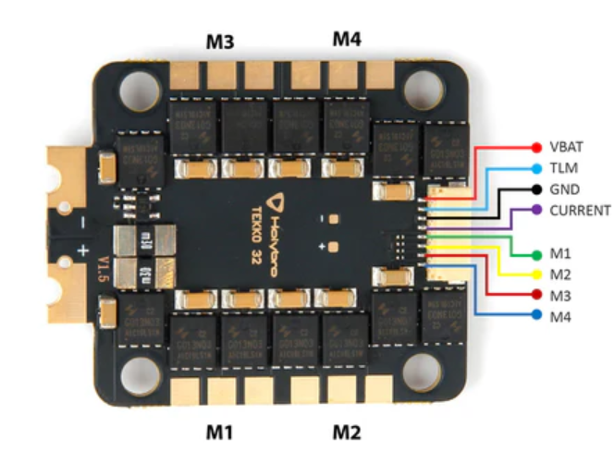

**Step 4**: Then take the Raspberry Pi mount plate and insert the M3 nut insert( 4mm length) into the mounting hole for Raspi.

**Step: 5** On the Raspberry Pi 4 model attach the fan shimp( cooling fan) in the Raspberry Pi.

**Step: 6** Then mount it in the Raspberry Pi base plate(refer image given),

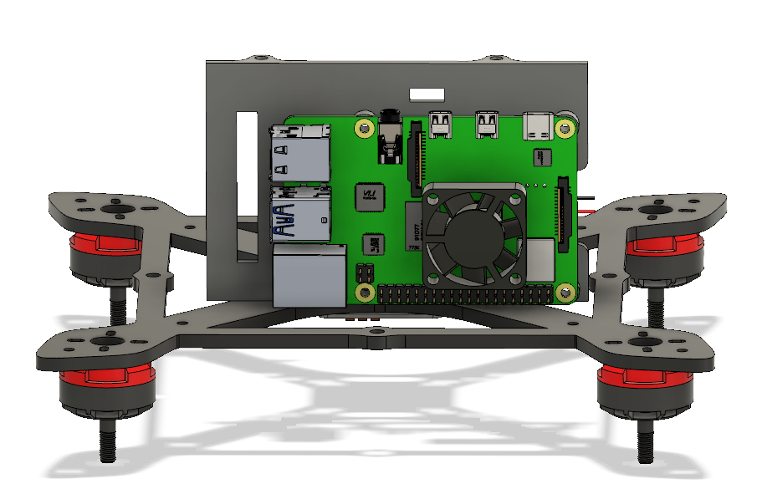

Similarly, we have to mount the component in the Electronics base plate but before that, we have to make a customized power module,

**Customization of Power Module for Safe Battery Power Distribution:**

**Step: 8**

**Preparation:** Begin by carefully removing the connectors at both ends of the power module, ensuring precise handling to avoid damage to internal components.

**Step: 9**

**Selection of XT60 Connector:** Select an XT60 connector suitable for the power requirements of the Fury_4 drone, taking into account factors such as current rating and compatibility with existing wiring

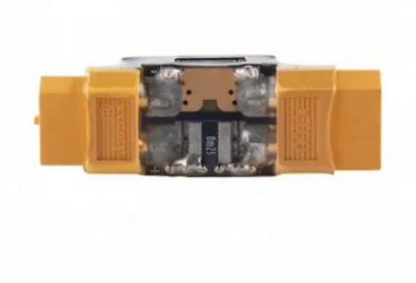

**Step: 10**

**Soldering Procedure:** With meticulous attention to detail, solder the XT60 connector to the power module, and also solder the red and black wire of [jst 2 pin connector](https://robu.in/product/jst-male-2-pin-connector-set-10pcsset/)( for separate power supply for raspberry pie) into the positive and negative terminal adhering to correct polarity to prevent electrical damage and ensure compatibility with standard battery connectors.

**Step: 11  
Inspection and Testing:** Thoroughly inspect the solder joints for proper connection and integrity, verifying polarity alignment and continuity. Conduct comprehensive testing to validate the functionality and safety of the customized power module before integration into the drone assembly.

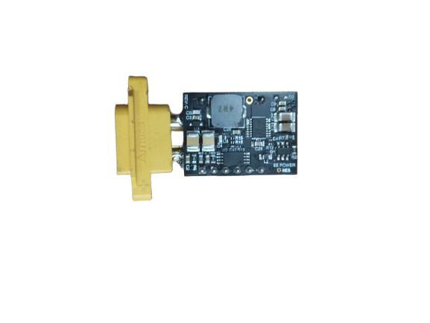

**Step12**:

Once the power module has been customized with the XT60 connector, the next step is to integrate it with the UBEC (Universal Battery Eliminator Circuit). This critical component plays a pivotal role in regulating voltage levels and providing clean, stable power to the electronic systems of the Fury drone

**Step:13**(optional) 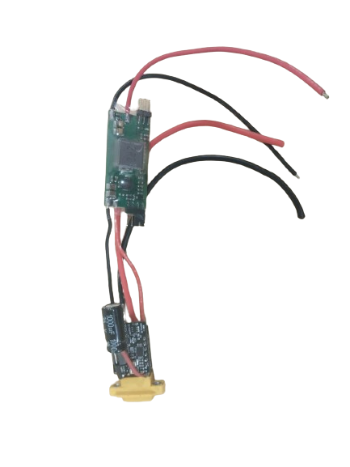

In the above image, you can see the capacitor is also attached to the power brick capacitor has a major role in it

**Role of Capacitors in ESCs:**

* **Noise Reduction:** Capacitors filter out electrical noise generated by ESCs and motors, ensuring a clean power supply to other components.
* **Voltage Stabilization:** Capacitors stabilize voltage output, preventing voltage fluctuations that could affect motor performance or damage electronics.
* **Protection:** Capacitors protect ESCs and other components from voltage spikes and surges by absorbing excess energy.
* The primary use of a capacitor to store the electrostatic energy in an electric field and supply this energy whenever possible to the circuit.

**Step 14:**

After customizing the power brick we can attach the component to the electronics base plate needed to be installed on the carbon fiber main body.

**Step: 16** Then we have to mount the middle frame of carbon fiber (2mm Thickness) with the help of the [M3 (35mm)spacers](https://www.quadkopters.com/product/hardware-and-accessories/m335-aluminum-spacers-with-grip/) mount the middle frame of carbon fiber plate with 8 M3 (35mm)spacers after it will look like this as it is shown in the below image

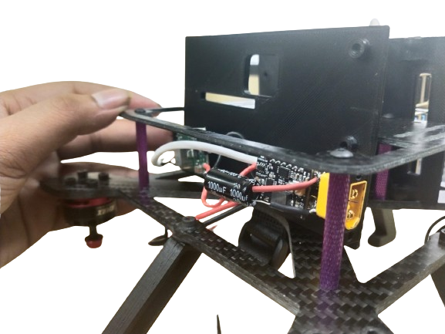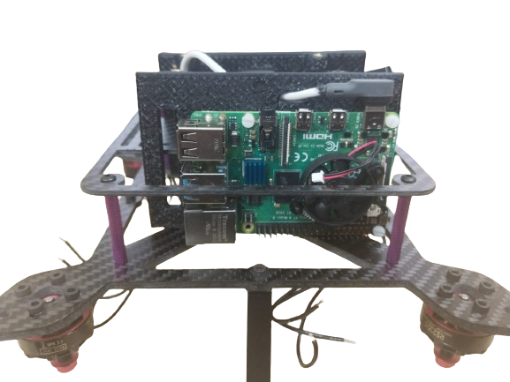

**Step: 17**

In the image we can see we passed a USB cable that cable is customizable we removed the end of the USB cable connecter,

**Step: 18** Connect the red and black wire we get after removing the connecter,

**Step: 19** Connect negative(black) and positive(red) wires to both terminals of the UBEC output terminal also keep its polarity as it required do not interchange the wire it might damage the component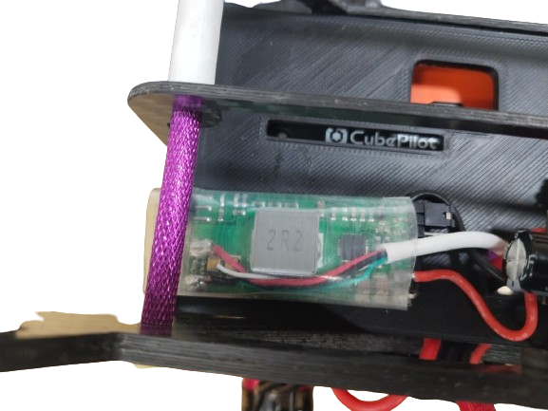

Some usb have green and white wire that we have to cut also we have to be careful with both green and white wire while powering they should not touch it would be better to cut them.

**Step: 20** Also mount the [RC Receiver](https://robu.in/product/x6b-2-4g-6ch-bus-ppm-pwm-receiver-afhds/) using a M2 x 8mm screw as shown in the image.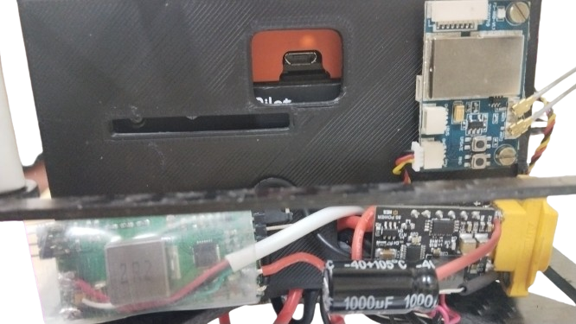

The receiver is mounted on electronic component mounting plate in the top right corner

**Step: 21** Mount the pixhawk in the middle of both electronic component and raspberry pi plates on 2nd middle carbon fiber plate as it shown in the below image 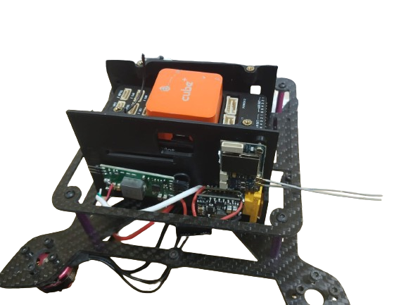

We can use double-sided tape to stick the flight controller on the carbon fiber plate

**Step: 22** Now we have to mount the ESC in the bottom frame (base frame) and keep the connection inside it will be easy to mount the ESC with the frame.

**Step: 23** Solder the wire of positive and negative coming from the power module in the front

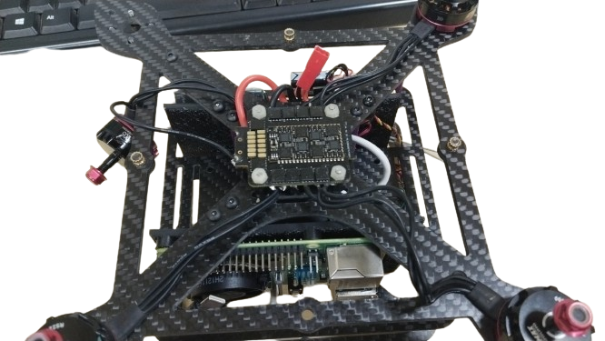

positive and negative terminal.

**Step: 24** Mount the ESC by keeping a gap of 10mm from the carbon fiber main body to avoid electrical contact. Use a M3x12mm nylon standoff for this, and tighten using a nylon nut from the top.

**Step: 25** Connect the ppm Port situated on the RC receiver to the pixhawk RC In port with the receiver cable.

**Step: 26** Connect the in-power module to pixhawk (power 1 port) using the cables that comes with the power brick.

**Step: 27** Connect the ESC and Pixhawk for the motor wiring( Motor 1, 2, 3, 4 to pixhawk’s mains out 1,2,3,4 corresponding) and connect the ground pin from ESC to any free ground on Pixhawk’s main out(refer to images below)

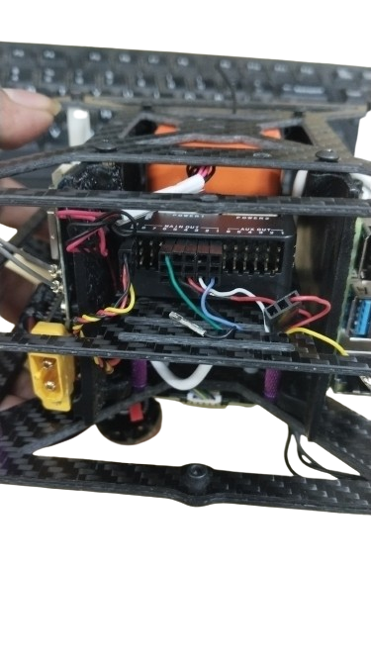

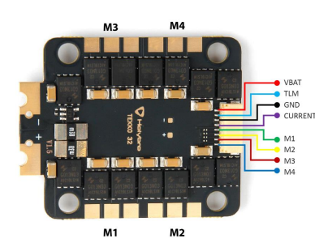

**Step 28:** After this mount the final carbon fiber plate( 2mm) with the help of 3D printed spacers( as shown in the below image with white color)by using the M3 screws (40mm)

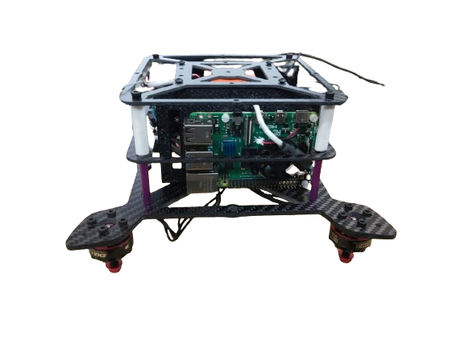

**Step:29** connect the [GenX 14.8V 4S 2200mAh 40C / 80C Premium Lipo Lithium Polymer Battery](https://robokits.co.in/batteries-chargers/genx-power-premium-lipo-battery/genxpower-14.8v-lipo-batteries/genx-14.8v-4s-2200mah-40c-80c-premium-lipo-lithium-polymer-battery?products_id=3880:0dd1bc593a91620daecf7723d2235624)

**Step: 30** Do all the necessary calibrations such as accelerometer, compass, and radio calibration. for more info visit the link below

<https://ardupilot.org/copter/docs/esc-calibration.html>

**Step: 31** Verify the direction of the motor as the right (right from the direction of the face) and its diagonal should be the same (counterclockwise) and the rest should be clockwise. Also, remove the propellers while performing the ESC calibration,   
These directions are done for our purposes; you can set directions to your specific requirements. If any motor is rotating in the wrong direction we have to swap any two wires out of 3 of that motor and the direction will be fixed for more info visit the below link

[Motor: https://ardupilot.org/copter/docs/connect-escs-and-motors.html](https://ardupilot.org/copter/docs/connect-escs-and-motors.html)

**Step 32:** Mount the propeller in the motor (5X5.5 inches) considering the rotational directions.

Thank you for exploring the Fury drone documentation! We hope this comprehensive guide has provided valuable insights into the capabilities and design of this high-performance, multi-mission Autonomous Air Vehicle (AAV). As you continue your journey in the world of unmanned aerial systems, remember that Fury is more than just a machine—it represents innovation, collaboration, and the pursuit of excellence.

**Connections:**  
